Project Design Phase-II
Technology Stack (Architecture & Stack)
Date | 13 September 2026
Team ID | Enter your Team ID
Project Name | Medical Diagnostic Center – ServiceNow
Maximum Marks | 4 Marks
Technical Architecture
The Medical Diagnostic Center is implemented as a ServiceNow-based web application. Patients interact with the system through the ServiceNow Service Portal. The application uses ServiceNow tables to store patient, diagnostic test, appointment, payment and laboratory report information. Business Rules and server-side scripts automate backend processes such as appointment management and laboratory report generation.
Architecture Flow
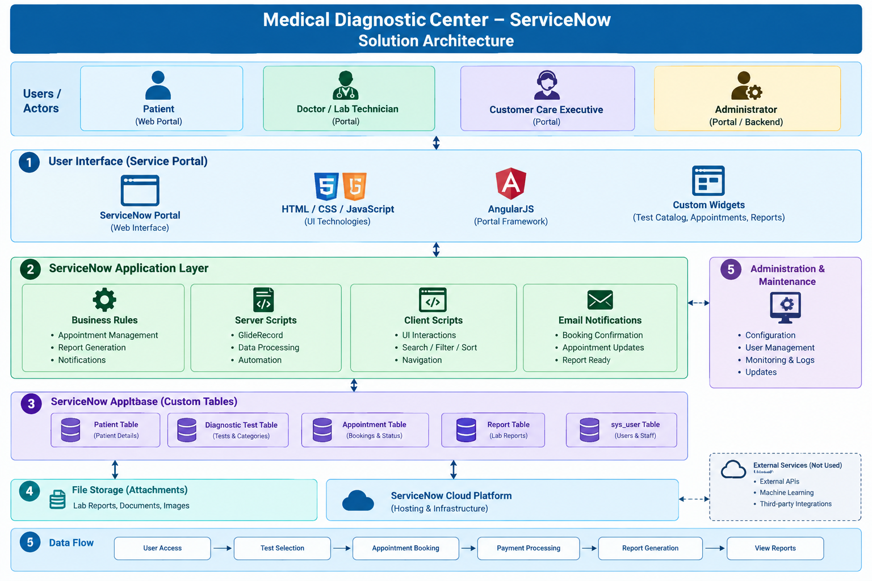

Table-1: Components & Technologies
S.No | Component | Description | Technology
1 | User Interface | Interface through which patients interact with the Medical Diagnostic Center application to browse tests, book appointments, make payments and view reports. | ServiceNow Service Portal, HTML, CSS, JavaScript, AngularJS
2 | Application Logic-1 | Handles appointment booking, cancellation, appointment status and other business processes. | ServiceNow Business Rules, JavaScript, GlideRecord
3 | Application Logic-2 | Handles client-side interactions such as search, filtering, sorting, navigation and modal views in portal widgets. | JavaScript, AngularJS, Service Portal Client Scripts
4 | Application Logic-3 | Automatically creates laboratory reports when an appointment is completed and manages report-related processing. | ServiceNow Business Rules, Server-side JavaScript, GlideRecord
5 | Database | Stores patient details, diagnostic tests, appointments, payment information and laboratory reports. | ServiceNow Platform Database / Custom Tables
6 | Cloud Database | Cloud-hosted data storage provided as part of the ServiceNow platform. | ServiceNow Cloud Platform Database
7 | File Storage | Stores files and attachments associated with records such as laboratory reports and other supporting documents. | ServiceNow Attachments / Platform File Storage
8 | External API-1 | External API integration is not required for the core implementation of the proposed solution. | Not Used
9 | External API-2 | External API integration is not required for the core implementation of the proposed solution. | Not Used
10 | Machine Learning Model | Machine learning is not required for the current implementation. The application focuses on diagnostic test booking and report management. | Not Used
11 | Infrastructure (Server / Cloud) | Application is developed, hosted and executed on the ServiceNow cloud platform/PDI environment. | ServiceNow Cloud Platform

Table-2: Application Characteristics
S.No | Characteristics | Description | Technology
1 | Open-Source Frameworks | The Service Portal uses web technologies and AngularJS-based portal functionality for building custom widgets and user interfaces. | HTML, CSS, JavaScript, AngularJS
2 | Security Implementations | Access to patient and application data is controlled through ServiceNow authentication, roles and access controls. Data is restricted according to user permissions. | ServiceNow Authentication, Roles, ACLs and Access Controls
3 | Scalable Architecture | The application uses the ServiceNow cloud platform and modular components such as tables, widgets, Business Rules and scripts. Additional tests, patients, appointments and reports can be added without redesigning the complete application. | ServiceNow Platform, Service Portal, Custom Tables
4 | Availability | The application is hosted on the ServiceNow cloud platform, allowing authorized users to access the application through the web portal when the platform is available. | ServiceNow Cloud Platform
5 | Performance | Client-side filtering and sorting are used in portal widgets, while server-side GlideRecord queries retrieve required records from ServiceNow tables. The application avoids unnecessary processing and displays relevant patient data. | AngularJS, JavaScript, GlideRecord, ServiceNow Platform

Technology Stack Summary
Layer | Technology Used
Frontend / UI | ServiceNow Service Portal
UI Development | HTML, CSS, JavaScript, AngularJS
Application Logic | ServiceNow Business Rules
Server-side Processing | JavaScript, GlideRecord, GlideSystem
Client-side Processing | JavaScript, AngularJS
Database | ServiceNow Custom Tables
File Storage | ServiceNow Attachments
Notifications | ServiceNow Email Notifications
Hosting | ServiceNow Cloud Platform
Development Environment | ServiceNow Personal Developer Instance (PDI)

Main ServiceNow Tables Used
Table | Purpose
Patient | Stores patient information
Diagnostic Test | Stores available diagnostic tests, categories and test details
Appointment | Stores patient bookings, dates, time slots, status and payment information
Report | Stores laboratory reports, findings, report status and verification details
User (sys_user) | Stores application users and authorized staff information

